## Requirements

* Wamp / Xamp
* VS Code
* Extensions:

## Installations:

composer create-project laravel/laravel laravell11-tutz

## Run:

php artisan serve

## Install Node Modules

npm install

npm run dev

## Folder Structure

1. **app**

* Http
  + Controllers
    - *Controller.php*
* Models
  + *User.php*
* Provides
  + *AppServiceProvider.php*

1. **bootstrap**

* *app.php* – Create an Application (routing,middleware,exceptions)
* *providers.php*

1. **config** – All configuration files
2. **database**

* factories
  + *UserFactory.php* - one factory for each model (define fields, how seed data)
* migrations
  + All migration files
* seeders

1. **public** – web accessible folder (all files here can be accessed in the browser)

* *index.php* – root/index

1. **resources**

* css
  + *app.css*
* js
  + *app.js*
  + *bootstrap.js*
* views
  + *welcome.blade.php*

1. **routes**

* *console.php*
* *web.php*

1. **storage**

* app
  + public
* framework
  + sessions
  + testings
  + views
* Logs
  + *laravel.log*

1. **test**
2. **vendor** – 3rd party packages
3. ***.env*** (config environment variables)
4. ***artisan*** – CLI
5. ***phpunit*** – unit test
6. ***vite.config.js*** – config for vite server

## Artisan Overview

php artisan list

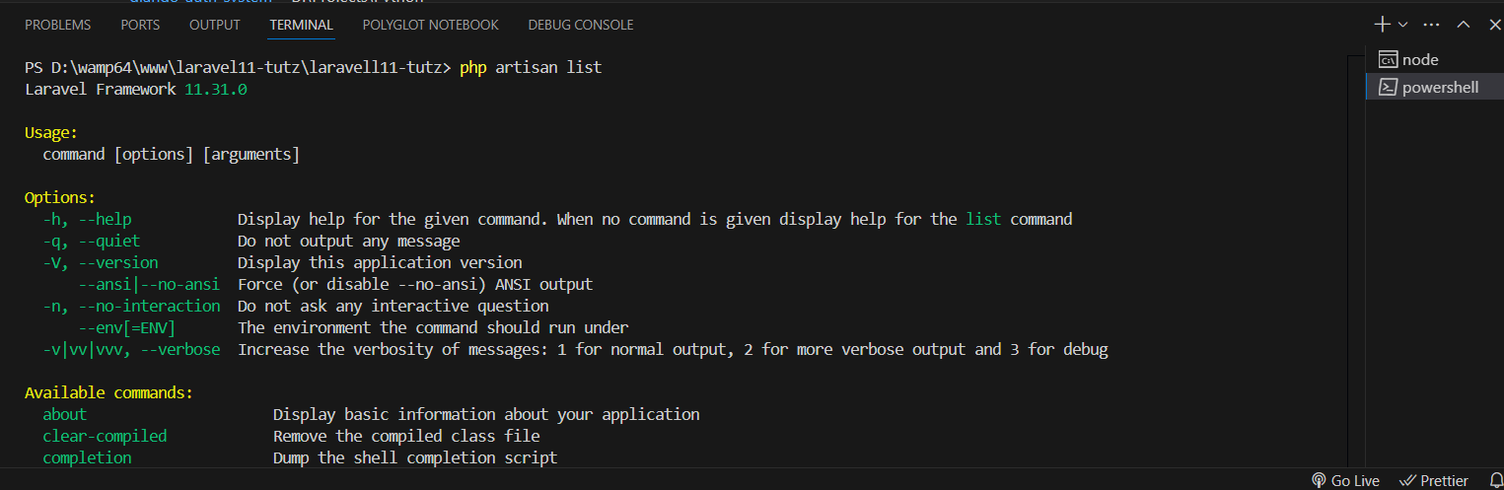

## Configuration Files

php artisan config:publish

* provide the name of the config file you want to publish
* you can delete any config files if you don’t use it
* you can also delete any code inside config files

php artisan config:publish *broadcasting*

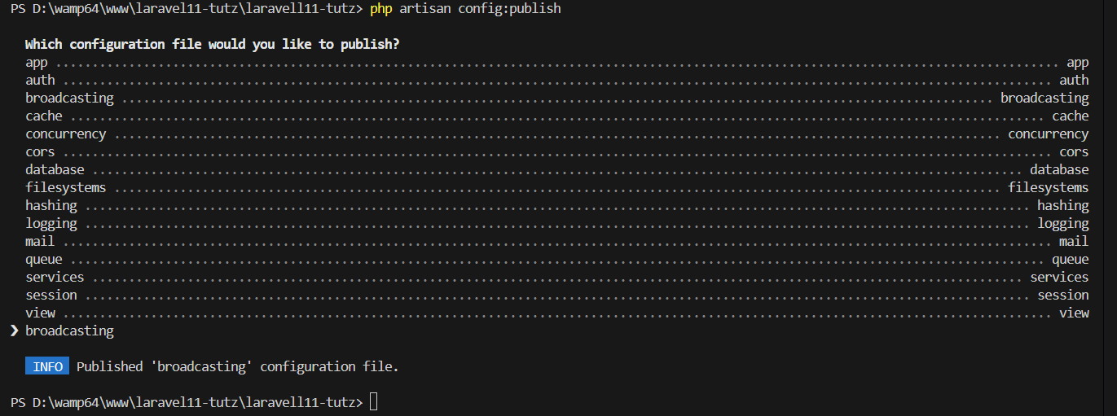

## Basic Route and Controller

Routes/web.php

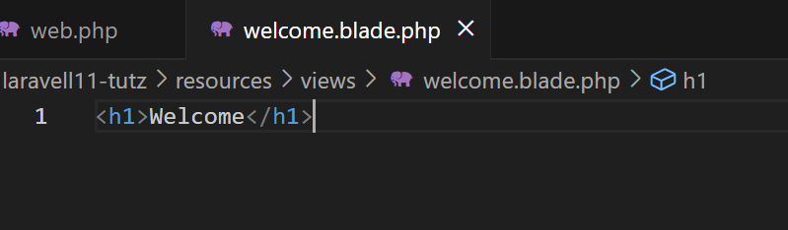

### Create Controller

php artisan make:controller WelcomeController

Create public function and render the view *welcome.blade.php*

### Modify the route

- call the controller and method (*welcome*)

## Eloquent Model & Migrations

php artisan make:model Note -m

Note – name of model

-m – create migration file as well

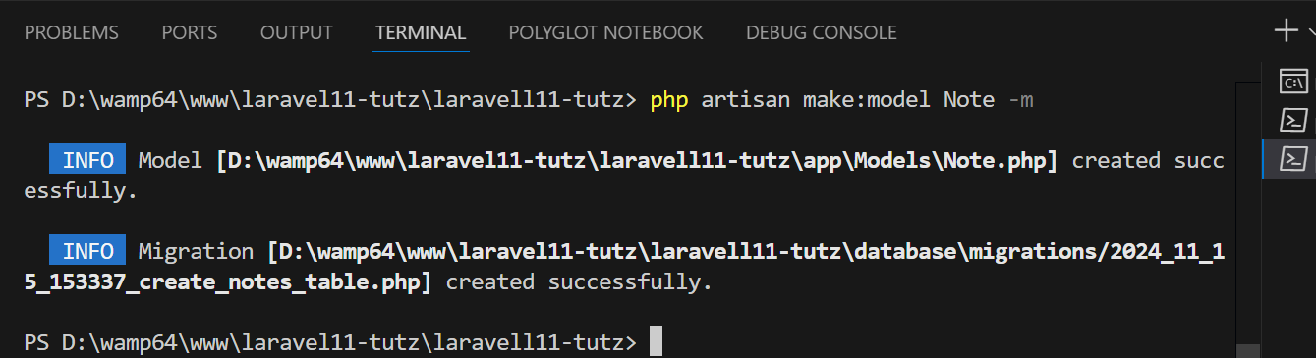

### The Model

### Migration file

#### Add mode columns

### Migrate

php artisan migrate

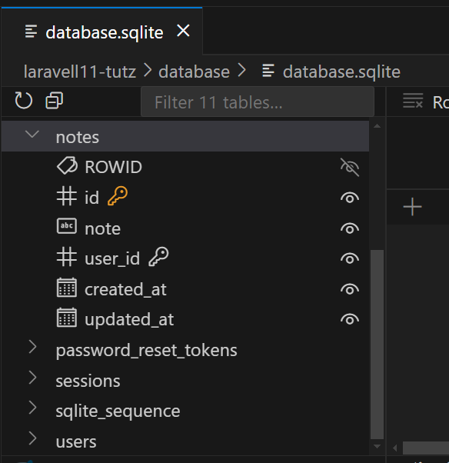

## Factory & Seed Data

### Create Factory

php artisan make:factory NoteFactory –-model=Note

or

php artisan make:factory NoteFactory

#### Modify return values

### Open Seeders/DatabaseSeeder.php

* add seeder for user (provide id & password)
* import Note model (*use App\Models\Note;* )
* create seeder for Note ( *Note::factory(100)->create();* )

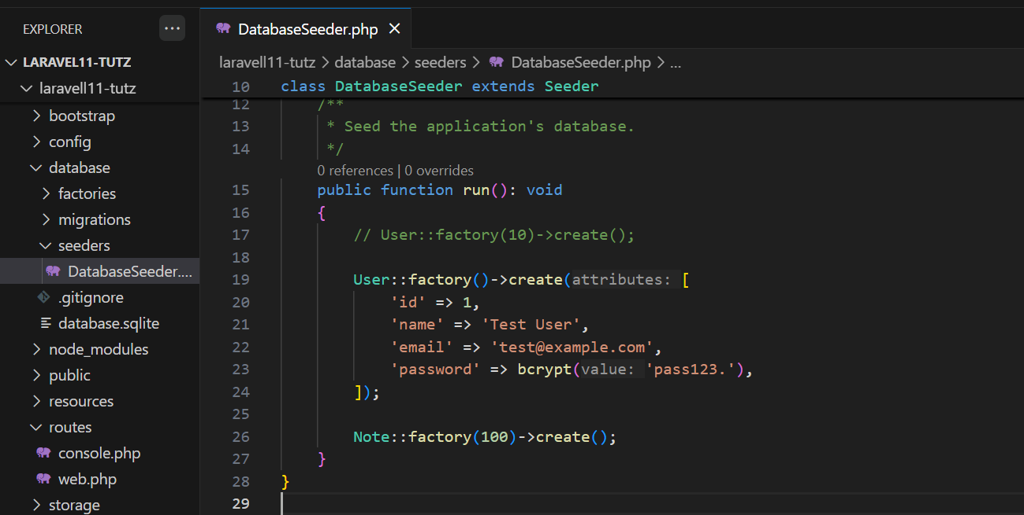

### Open Models/Note.php

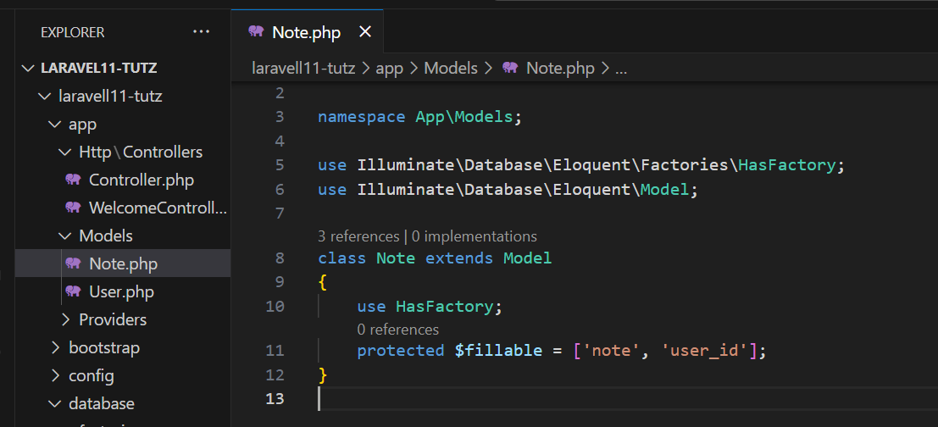

### Apply Seeder

1. php artisan db:seed

* create user and 100 notes in the database

1. php artisan migrate –seed

* migrate and seed

1. php artisan migrate:refresh --seed

* rollback all migration then re-apply and execute the seeder

## Generate Resource Controller

### Note Controller

php artisan make:controller NoteController --resource –model=Note

#### Return text for specific functions

## Resource Route

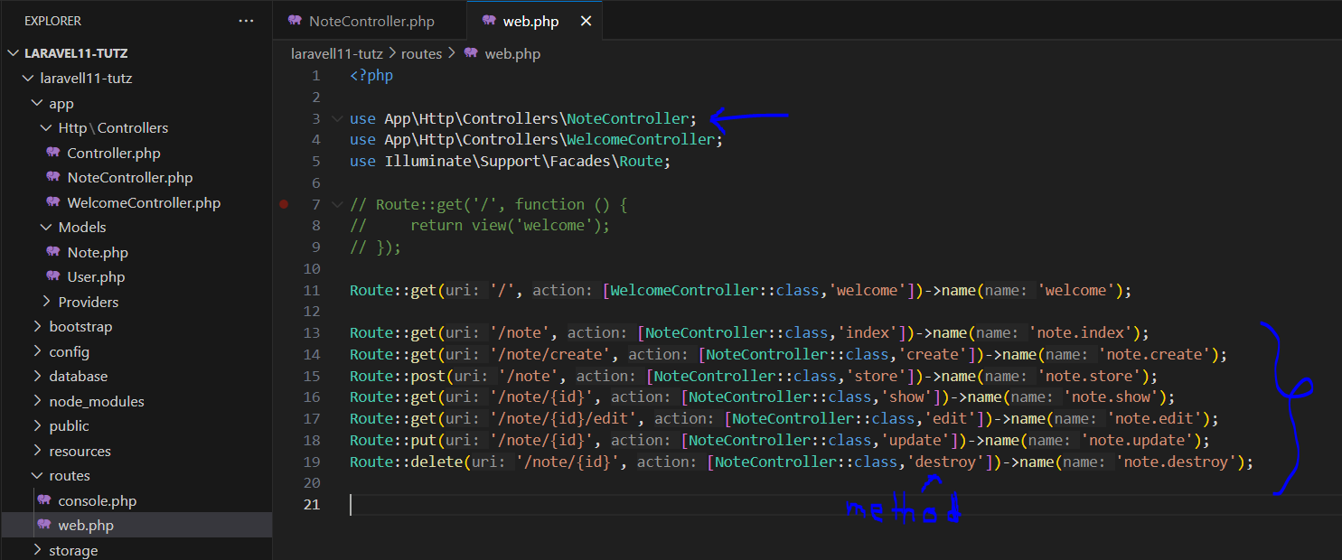

### Shorthand Route

## Views / Blade Files for CRUD

php artisan make:view note.index

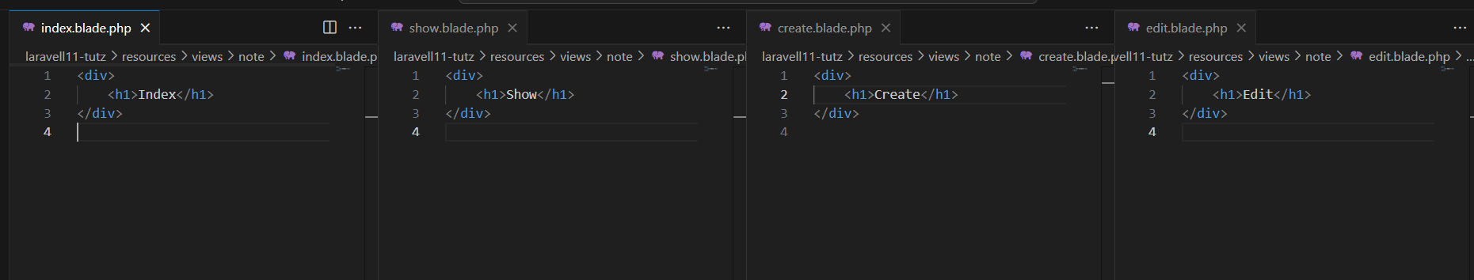

### Render the view in Controller

## Generate Layout

### Create Folder inside Views

views/components/layout.blade.php

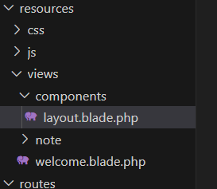

## Get All Notes / Render Notes

### Paginations

$notes = Note::query()->orderBy('created_at','desc')->paginate();

### Pass Data into View

Pass the $note object in Show & Edit methods

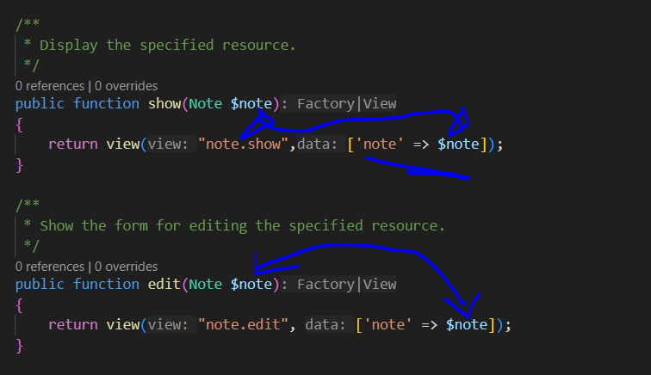

## Views/Note/Index.blade.php

### CSS Files

Linked the css in Layout using Vite Server

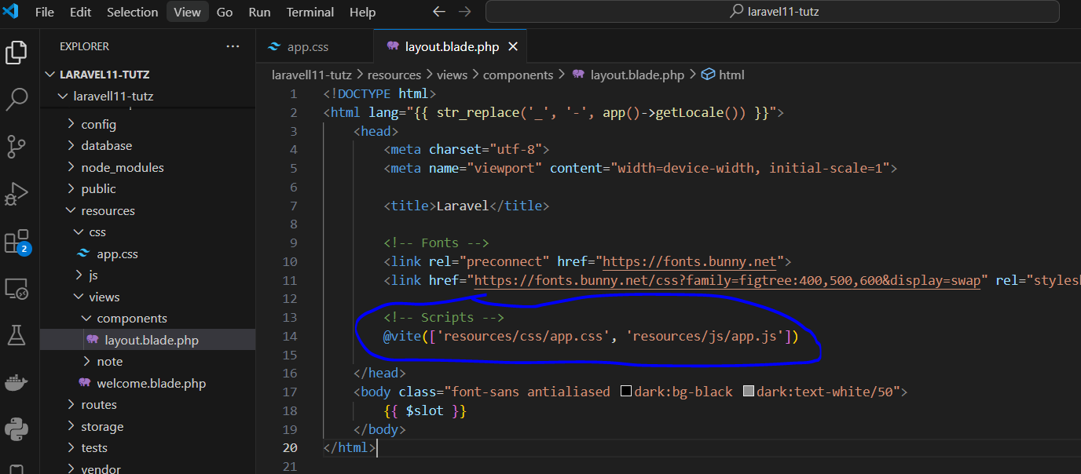

To build the css into the public folder, run:

npm run build

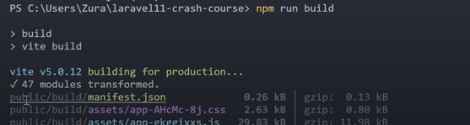

npm run dev

- using vite server for css from resource folder

npm run build

- for production (the css build into public folder)

## Views/Note/create.blade.php

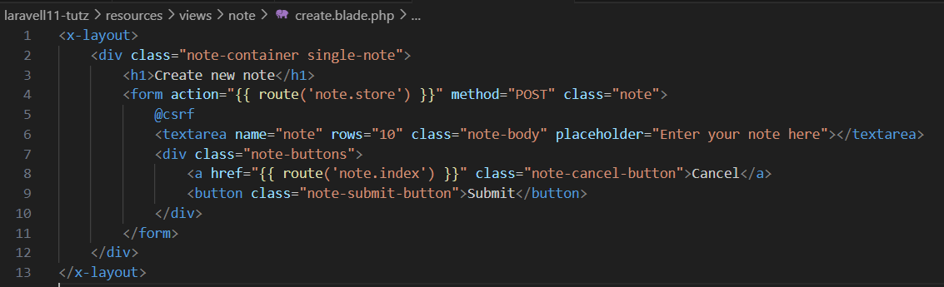

## Views/Note/show.blade.php

## Views/Note/edit.blade.php

## Create New Note

### NoteController(store)

### Models/Note.php

Add *@csrf* inside your Create Views Form

### @csrf

Display Message

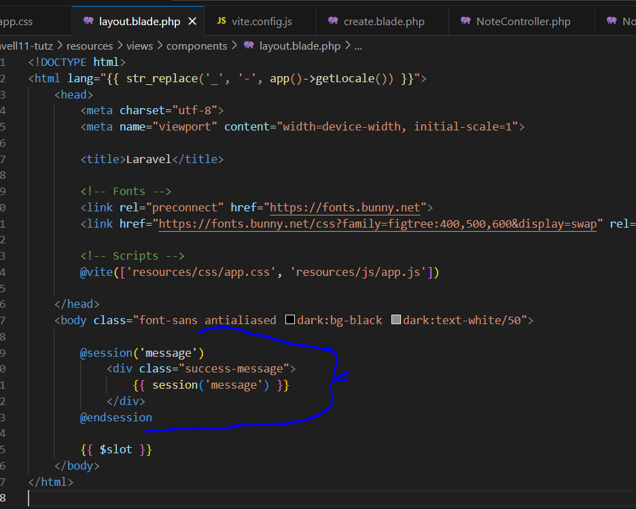

## Update Note

### NoteController(update)

Test

## Delete Note

### NoteController(destroy)

## Paginations

## Authentication

Notes: please backup your *resources/css/app.css* & *routes/web.php* first.

### Breeze

Command

composer require Laravel/breeze –dev

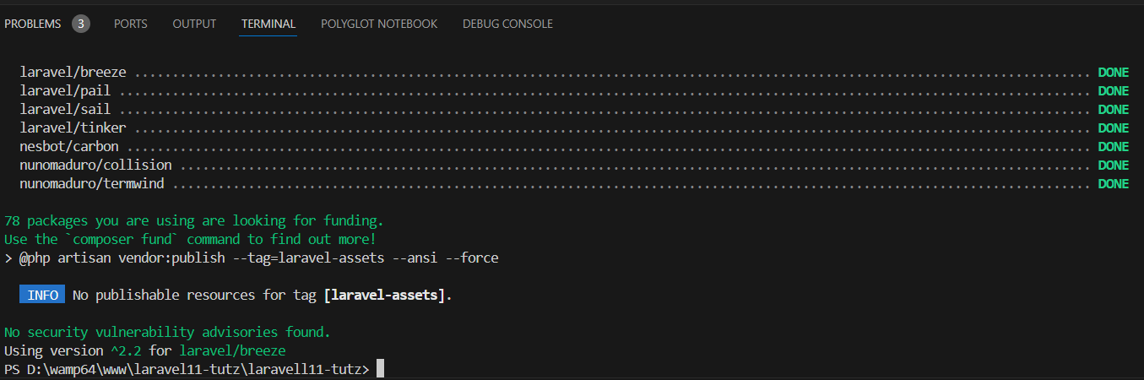

php artisan breeze:install

> blade

> no

> enter

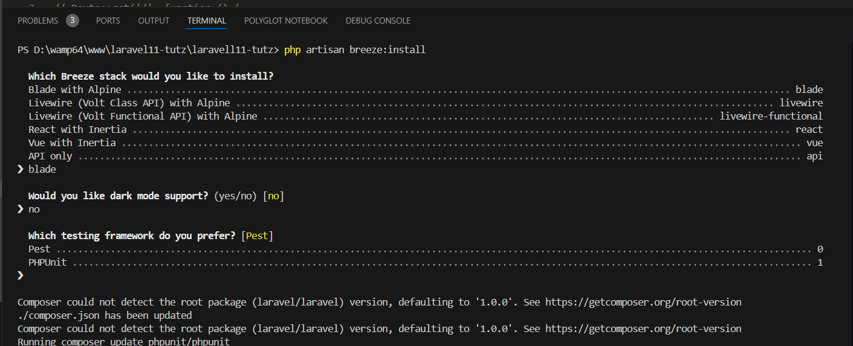

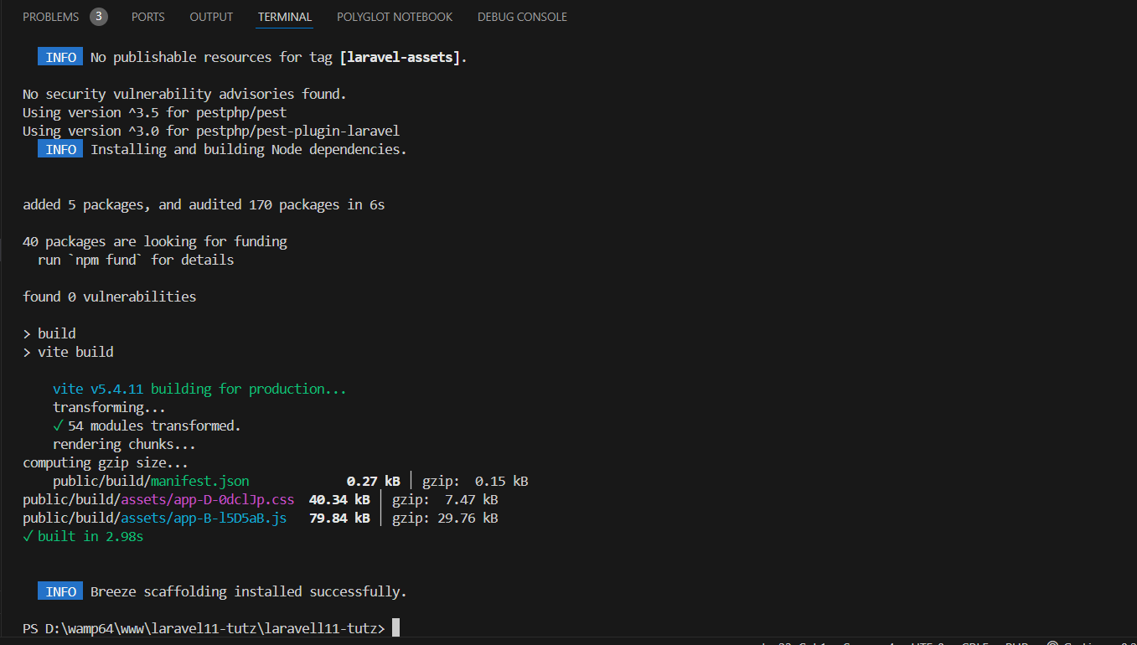

### Route

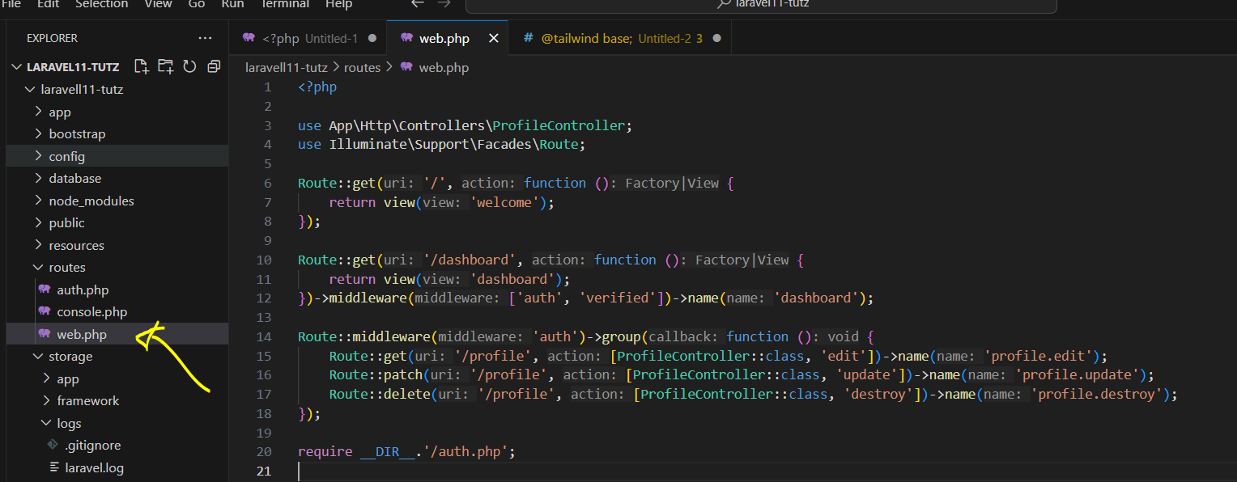

### Controller

### User Model

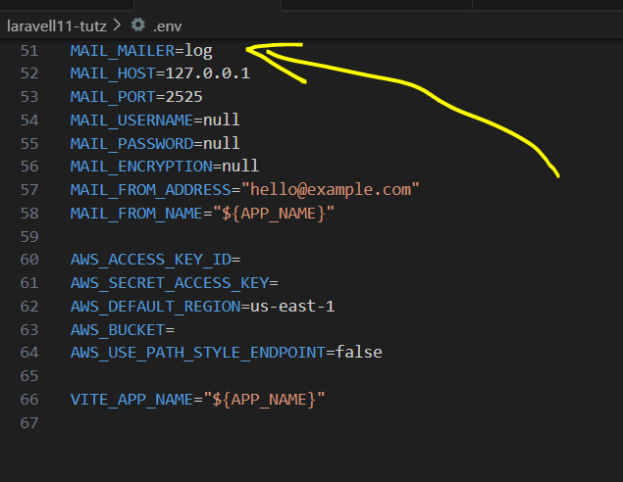

## Recover the Routes & CSS

### Use breeze dashboard layout

## Modify Note Controller for User

- only the owner can see his/her notes

- only the owner can edit/delete his/her notes

## Custom 403 Page

resources/views/errors/403.blade.php

## References

<https://youtu.be/eUNWzJUvkCA>

<https://github.com/thecodeholic/laravel11-crash-course>